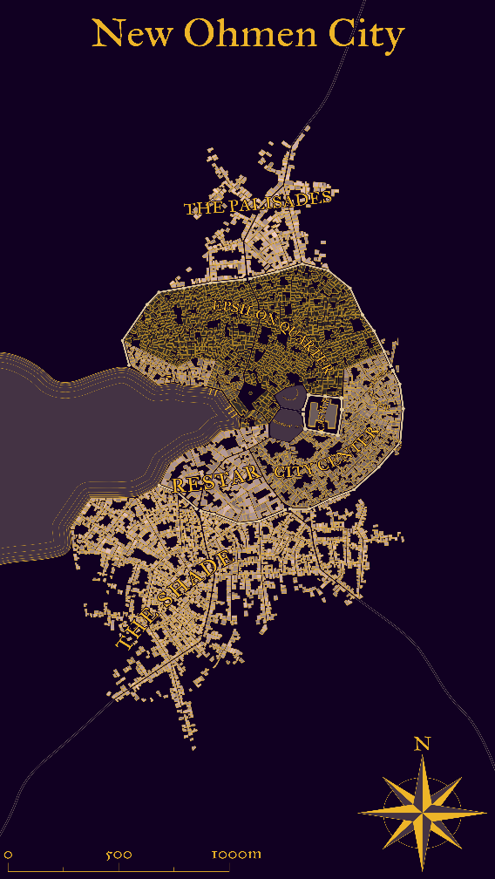
Seraph: New Ohmen City
Description: New Ohmen City serves as a satellite regional capital of the Elayan Continent. New Ohmen City is named in memory of the Empire’s former capital on Judecca in the Cocytus System. Established as an Imperial Culture Center, New Ohmen City is comprised of a modest fortress at the city’s center, encircled by several prominent districts. As a cultural center, New Ohmen City hosts the headquarters of the Imperial Mission, prominent arts and technical schools, a small financial district with a branch of the Caperion Intersystem Stock Exchange (CISE), and an Imperial Recruitment and Education Complex.
Located on the shores of the western sea, it is a short flight to Tokare and the former UCE Capital City. The weather is warm and dry, resembling that of the Mediterranean climate on Earth. Weather is typically defined by cool wet winters followed by warm dry summers. Natural disasters are uncommon in this area, but there has been some recorded tectonic activity which result in rare but small earthquakes.
New Ohmen city has a distinct architecture style. Buildings are made of red-brown sandstone, accented by fine jadelike stone. Metal features in the city are often made of a bronze-like metal, which tanish to a light blue green. Many have remarked that New Ohmen City bears a passing resemblance to Theed, capital City of Naboo, birthplace of Sheev Palpatine.
Unlike the rapid growth in Tokare and Corocova, the pace of life in New Ohmen City is much more laid back. Where Tokare has skyscrapers growing up seemingly overnight, New Ohmen city sticks to an “old world” style city layout.
To the North of the City is The Palisades Neighborhood, where the wealthiest citizens reside. South of The Palisades is the Episilon Quarter, where the majority of the city’s residents live. South of the Episilon Quarter is the City Center, where the Empire’s cultural center and financial district lies. Restar is to the west of the City Center and is the merchant’s district. Outside the walls to the south is The Shades. The Shades is a district of prefabricated apartment blocks which provides comfortable and economically viable housing for those who were displaced during the Caperion Civil War and the invasion of The Children of Mortis.

