The Emperor’s New Clothes

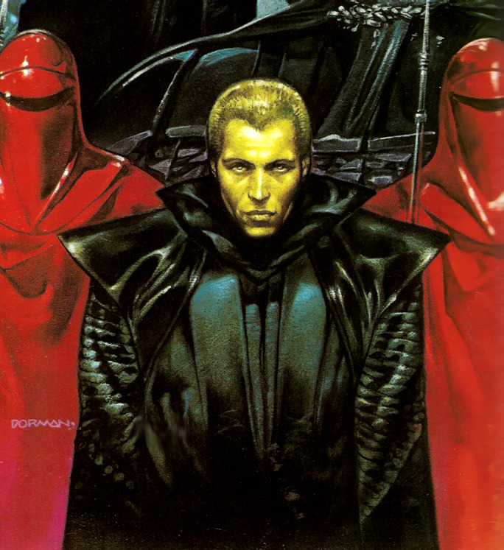Appearing at The Crimson Casino
aboard The Wheel
This Benduday at 20:00

