Droideka (Destroyer Droid) (rarity: Legendary)

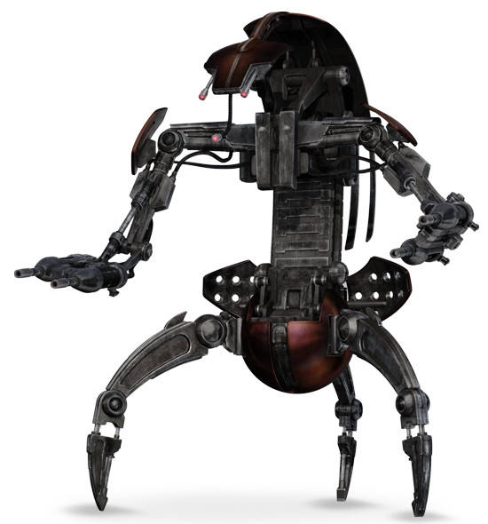
Item Image:

Image Source: https://starwars.fandom.com/wiki/Droideka

Type: Droid
Category: Combat Droid

Combat Droid Upgrade -

Droid Enhancement Upgrade -

Droid Structural Upgrade -

Item Aspect/Upgrade Slots available:

200,000 credits

The Droideka is a 3 legged droid capable of slowly moving using its 3 legs or transforming into a sphere like shape and rolling at exceptional speed (up to 75 kilometers per hour across a surface). It can rapidly damage enemy targets with its 2 twin repeating blaster cannons. The droid is covered in bronzium armor and is capable of emitting a spherical deflector shield around itself while it is in the 3 legged configuration. The droid is capable of firing its blasters while the shield is up. These shields can absorb damage from anything short of a blaster cannon but can be pierced by slow or stationary objects.

